37th Annual
Georgia TESOL Conference

Making Relevant Connections
Practice
Policy
Research

Georgia International Convention Center
September 28th – 29th, 2018
Atlanta, GA
Making Relevant Connections
Practice
Policy
Research

Welcome to the 37th annual Georgia TESOL Conference!
Our conference theme speaks to the need for all educators to stay abreast of changes in the field that might impact student achievement or their sense of hope for the future. It is empowering to be a member of an enduring community of educators who gather annually to share knowledge and advocate for student success.
As you attend large general sessions and concurrent sessions over the next two days, please remember our conference theme - Making Relevant Connections
- Research should be useful and relevant in order to inform educational decisions. Attend concurrent sessions regarding pertinent research that undergirds best practices.

- Policy drives ESOL administration. Attend large general sessions to hear the latest policy decisions that impact program administration and student achievement.

- Practice is the heart of this conference. Attend concurrent sessions to share the experiences of colleagues who teach in a variety of settings. You will gain powerful techniques and strategies.
I believe that discussion and engagement among colleagues that focuses on improving the educational experience and lives of our students is a worthy endeavor. Finally, remember to network so that the exchange of information continues throughout the year. Enjoy the conference.
Warm regards,

Lela Horne, Ph.D.
2018 Georgia TESOL Conference Chair

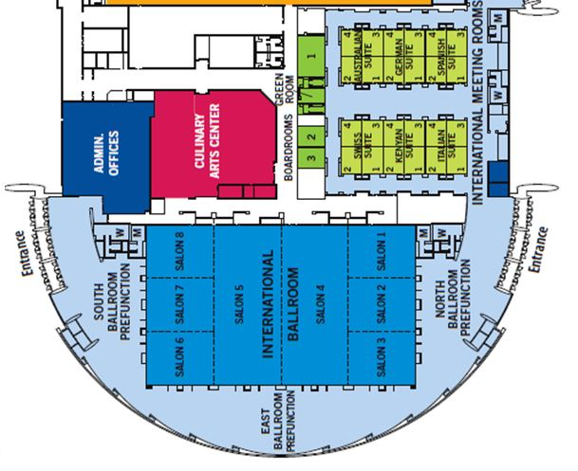

Friday
September 28, 2018

7:30-4:00 Registration North Ballroom Pre-function

8:00-8:25 Newcomer Session Suites

8:30-9:30 Welcome/Opening Session Salons 4-5
(Rep. Bee Nguyen
Georgia House Representative)

9:45-10:30 Concurrent Sessions Suites

10:00-10:45 Plenary Salons 1-2
(Lorraine Irier, Attorney
Office of Civil Rights)

10:45-11:30 Concurrent Sessions Suites

11:45-1:00 Lunch/Keynote Salons 4-5
(Jose Viana, Director
Office of English Language Acquisition)

1:15-2:00 Concurrent Sessions Suites

2:00-2:40 Plenary Salons 1-2
(John Segota, Associate Executive Director for Public Policy
& Professional Relations, TESOL International)

2:15-3:00 Concurrent Sessions Suites

3:15-4:00 Concurrent Sessions Suites

4:30-6:00 Poster Session/Reception Pre-function Area

Suites: Italian, Kenyan, Swiss, Spanish, German, and Australian
Saturday
September 29, 2018

7:00-1:00 Registration Pre-function Area

8:00-8:25 GATESOL Interest Sections Suites

8:30-9:30 Business Breakfast Salons 4-5

9:45-10:30 Concurrent Sessions Suites

10:00-10:45 Large Concurrent Session Salons 1-2
Green Card Voices

10:45-11:30 Concurrent Sessions Suites

11:45-1:00 Lunch Salons 4-5
(Dr. Serena Walker, Technical College System of Georgia &
Ms. Stephanie Rooks, Dean of Adult Education, Gwinnett Technical College)

1:15-2:00 Concurrent Sessions Suites

2:00-2:40 Large Concurrent Session Salons 1-2

2:15-3:00 Concurrent Sessions Suites

3:15-4:00 Concurrent Sessions Suites

Suites: Italian, Kenyan, Swiss, Spanish, German, and Australian

Policy Experts

Representative Bee Nguyen, District 89 Opening Remarks
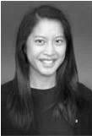

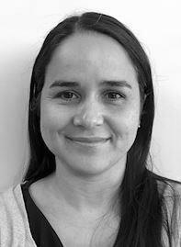

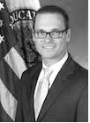
Georgia House of Representatives Salons 4-5, 8:30-9:30
Atlanta, GA

Bee Nguyen is the representative for Georgia House District 89, which includes City of Atlanta and DeKalb Counties. Bee currently serves on the House Human Aging & Relations, Governmental Affairs, and Education committees, where she fights to preserve voting rights and full funding for Georgia public schools. How will she partners with educators for the benefit of ELs? What state policies will be on the House agenda this year?

Lorraine Irier, Esq. Friday Morning Plenary
Attorney, U.S. Dept. of Education Salons 1-2, 10:00-10:45
Office of Civil Rights

Ms. Irier will present an overview of the most pertinent OCR policies that impact
ESOL administration. What is required for LEP Parent Communication? What
Are the requirements for EL student access to Gifted and Talented Programs? What are proper policies and procedures for undocumented high school ELs? Learn about these topics and more to hopefully avoid an OCR compliance review.

Jose Viana, Director Friday Luncheon Keynote
Office of English Language Acquisition Salons 4-5, 11:45- 1:00
Washington, DC

Jose Viana was once an ESOL student who later became an ESOL teacher. Now, he is the Director of the Office of English Language Acquisition (OELA) in Washington, DC. How will his experiences shape his vision for OELA? Which national initiatives might impact Georgia classrooms? What is the future of the Office of English Language Acquisition?

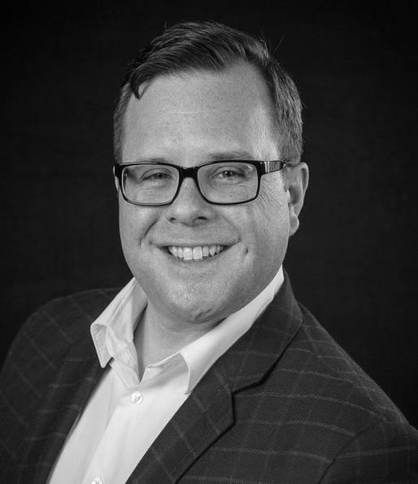

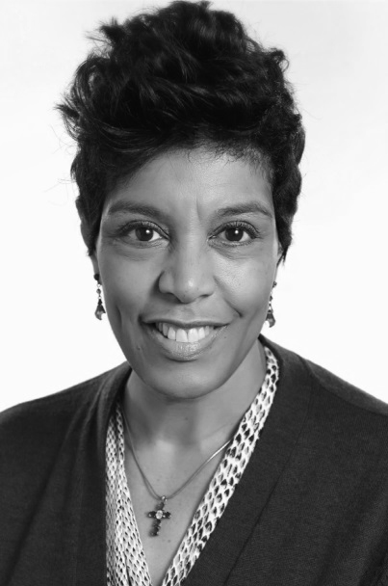
John Segota Friday Afternoon Plenary
Associate Executive Director for Salons 1-2, 2:00-2:40
Public Policy & Professional Relations at
TESOL International
Washington, DC

Do you know how to effectively advocate for your students? Do you want to learn? Don’t miss this opportunity to gain practical knowledge regarding local advocacy within a national context. Mr. Segota will give a plenary address followed by workshops during concurrent sessions on Friday and Saturday.

Dr. Serena Walker Saturday Keynote Speakers
Grants Director, Workforce Division Salons 4-5, 11:45- 1:00
Technical College System of Georgia

Ms. Stephanie Rooks
Dean of Adult Education
Gwinnett Technical College

Gwinnett Technical College is the largest and most successful adult ESL program in the state. How does federal policy impact program administration and contribute to their success? Can we duplicate their process? These joint keynote speakers will reveal the secrets to their successful collaboration.

